Apr 13, 2023

ECE 528: 002: Cloud Computing

Professor: [Nevrus Kaja](mailto:nkaja@umich.edu)

Group 24: [Amritha Suresh](mailto:amsuresh@umich.edu)[Sai Joshitha Kathari](mailto:skathari@umich.edu)[Keerthana Turlapati](mailto:keertht@umich.edu)

Final Project Paper: E-Commerce Recommendation System

**FINAL PROJECT PAPER**

**Motivation and Problem Statement:**

Explore the possibilities of integrating Google Cloud Platform, a webpage and third-paty chatbot. There are not many e-commerce jewelry stores that has a recommendation engine or a chatbot to assist customers with shopping jewelry. Hence, came up with the idea of creating a jewelry store e-commerce website with a recommendation system and a chatbot to assist customers with shopping.

**Architecture Choices:**

Prototype 1:

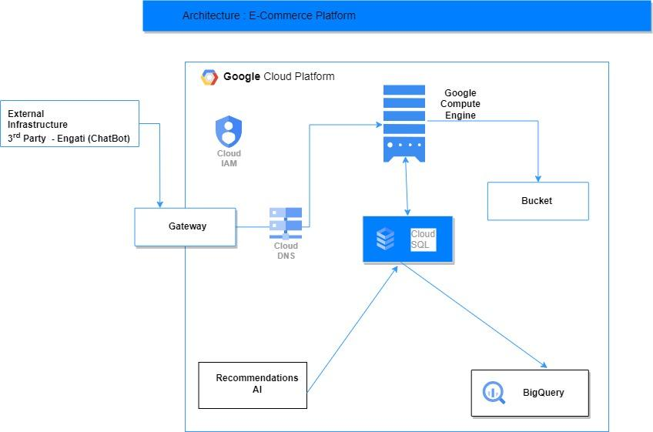

Prototype 2:



Prototype 3:

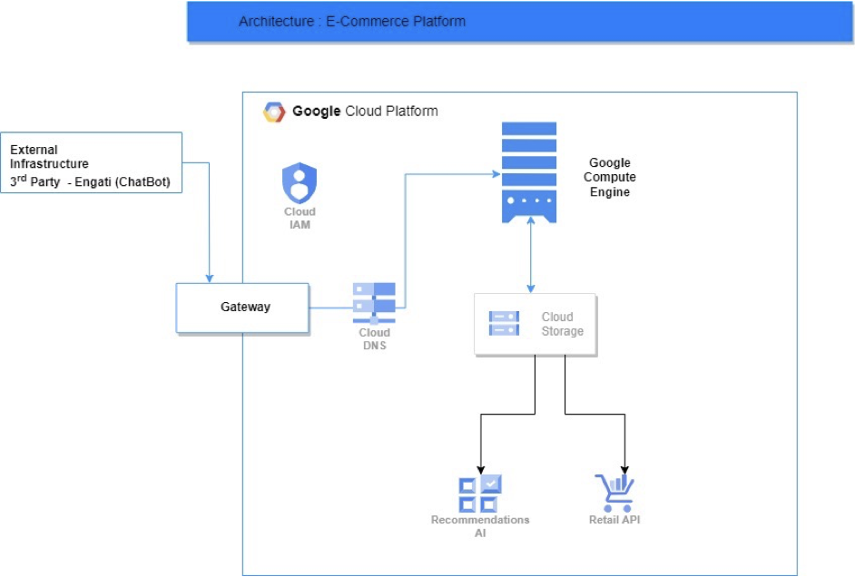

**Presentation of Results:**

**Step 1:**

Our Website is a jewelry store which was developed using LAMP stack,

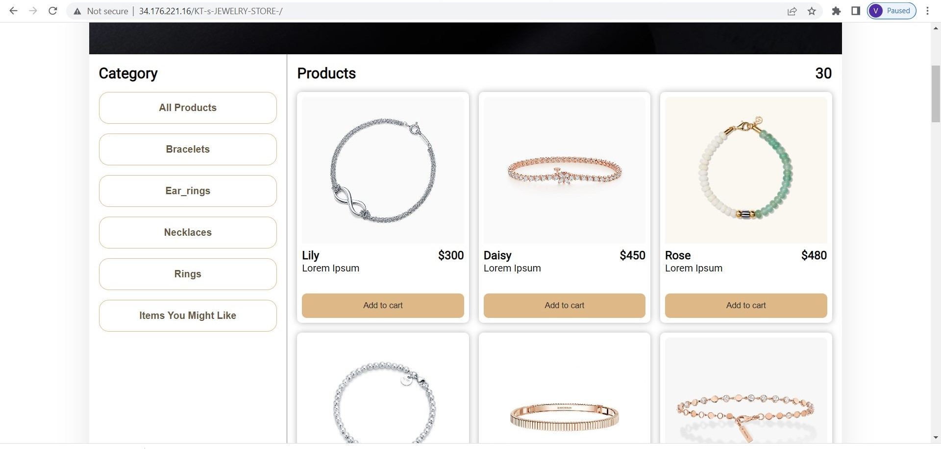

**Step 2:**

Hosted our website in Google Cloud Platform using Google Compute Engine

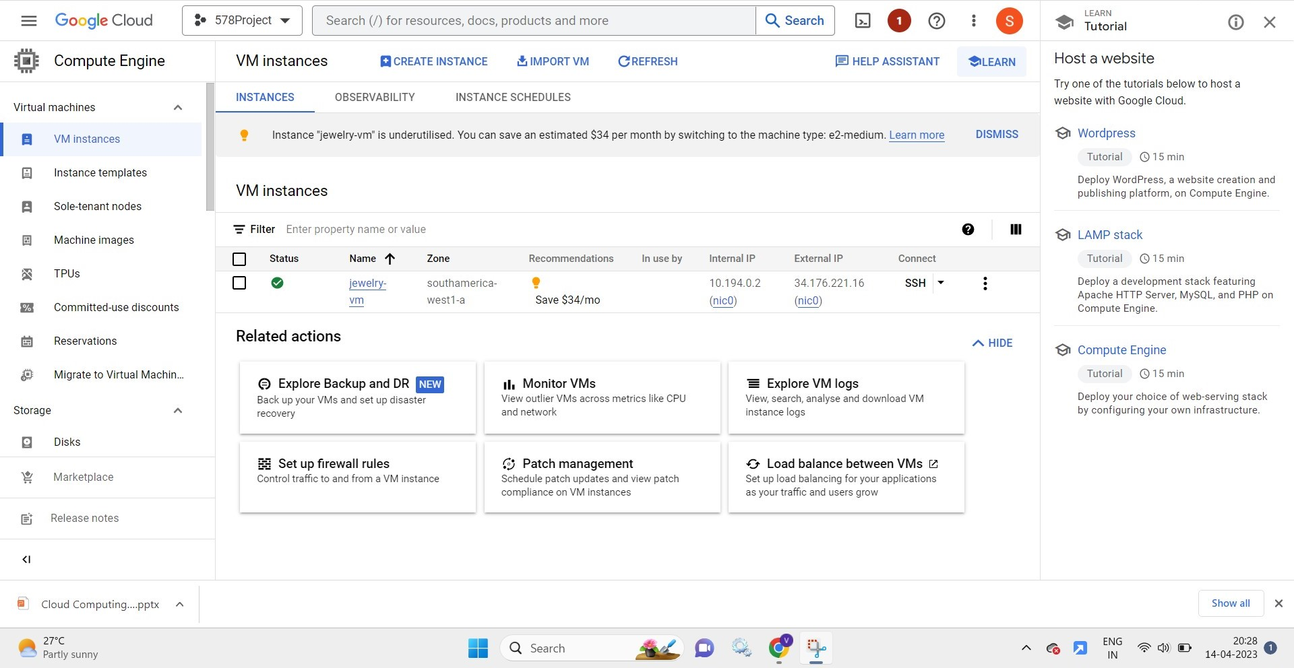

**STEP 3:**

We used Cloud Storage service to store our product details

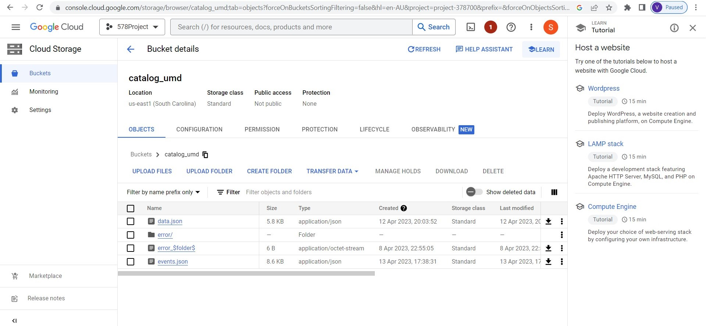

**STEP 4:**

We used Recommendation AI service to give recommendations to the customers about products based on their previous purchases and interactions

Here the generated user data was used to train the “Similar Items“ Recommendations.

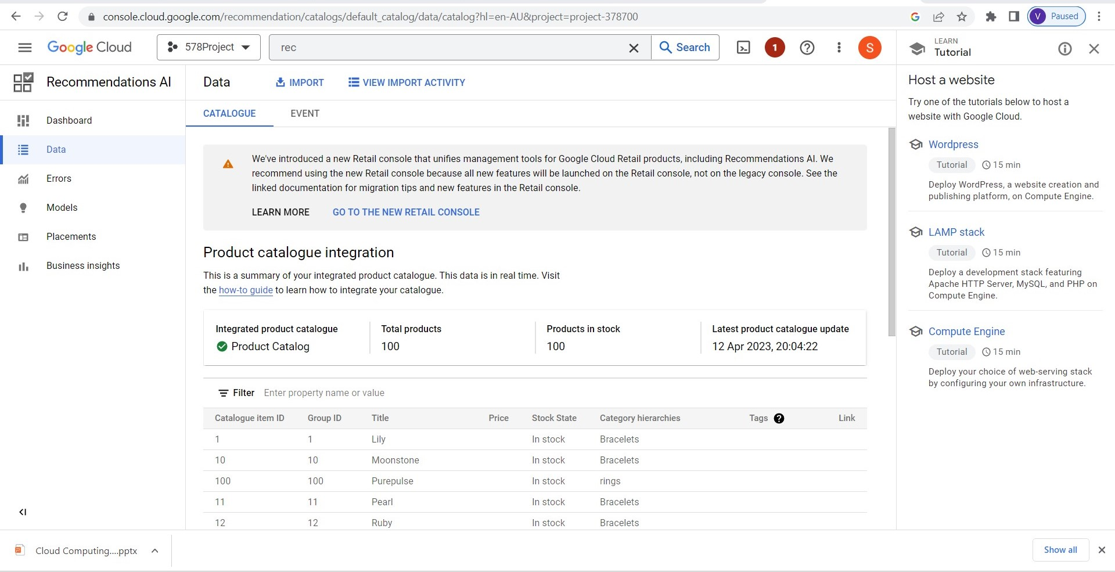

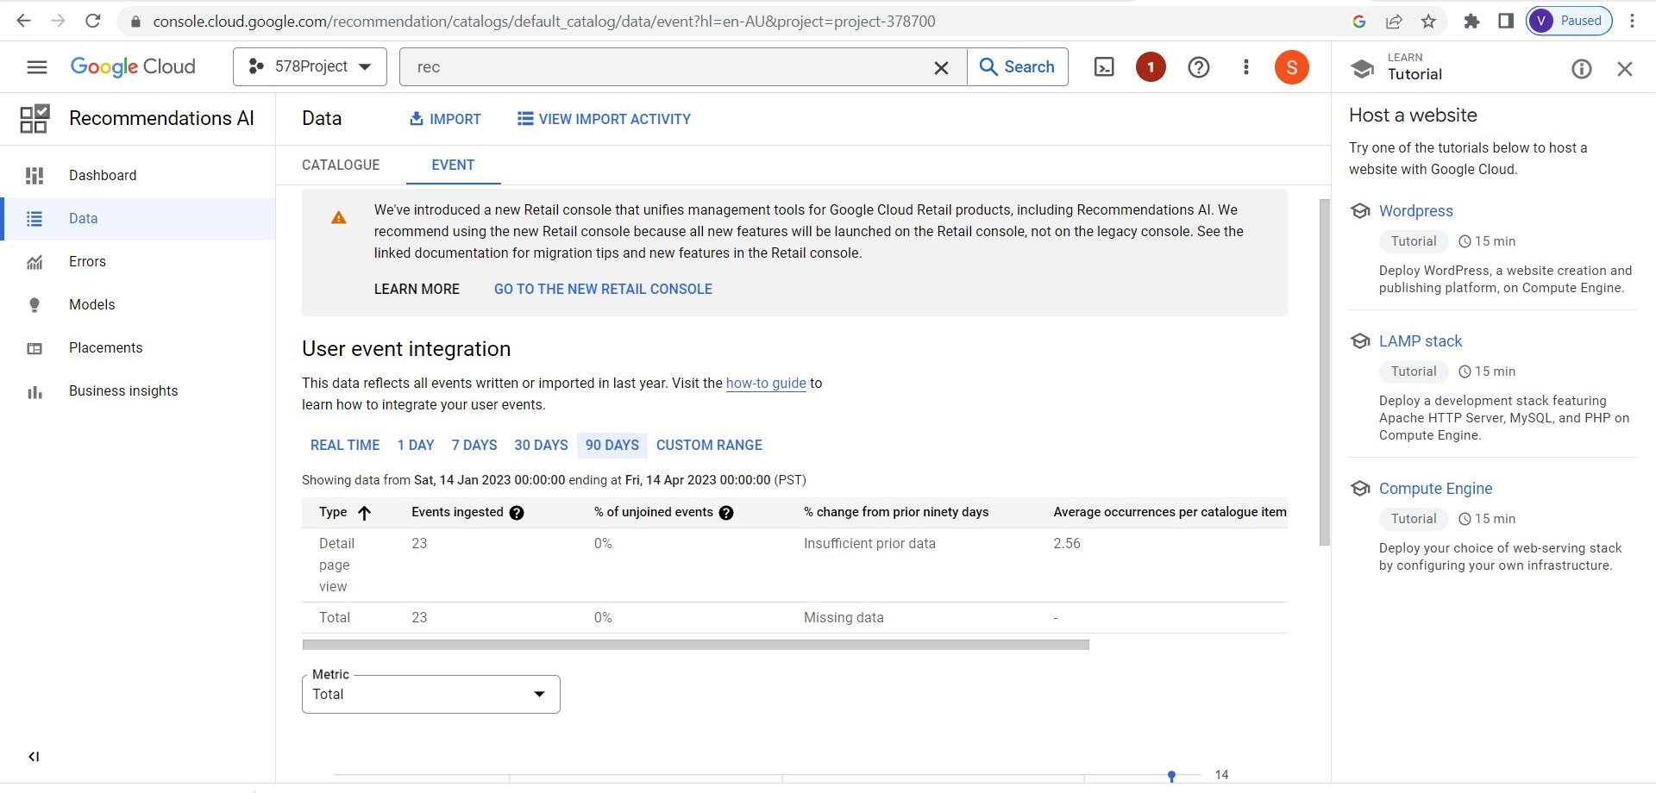

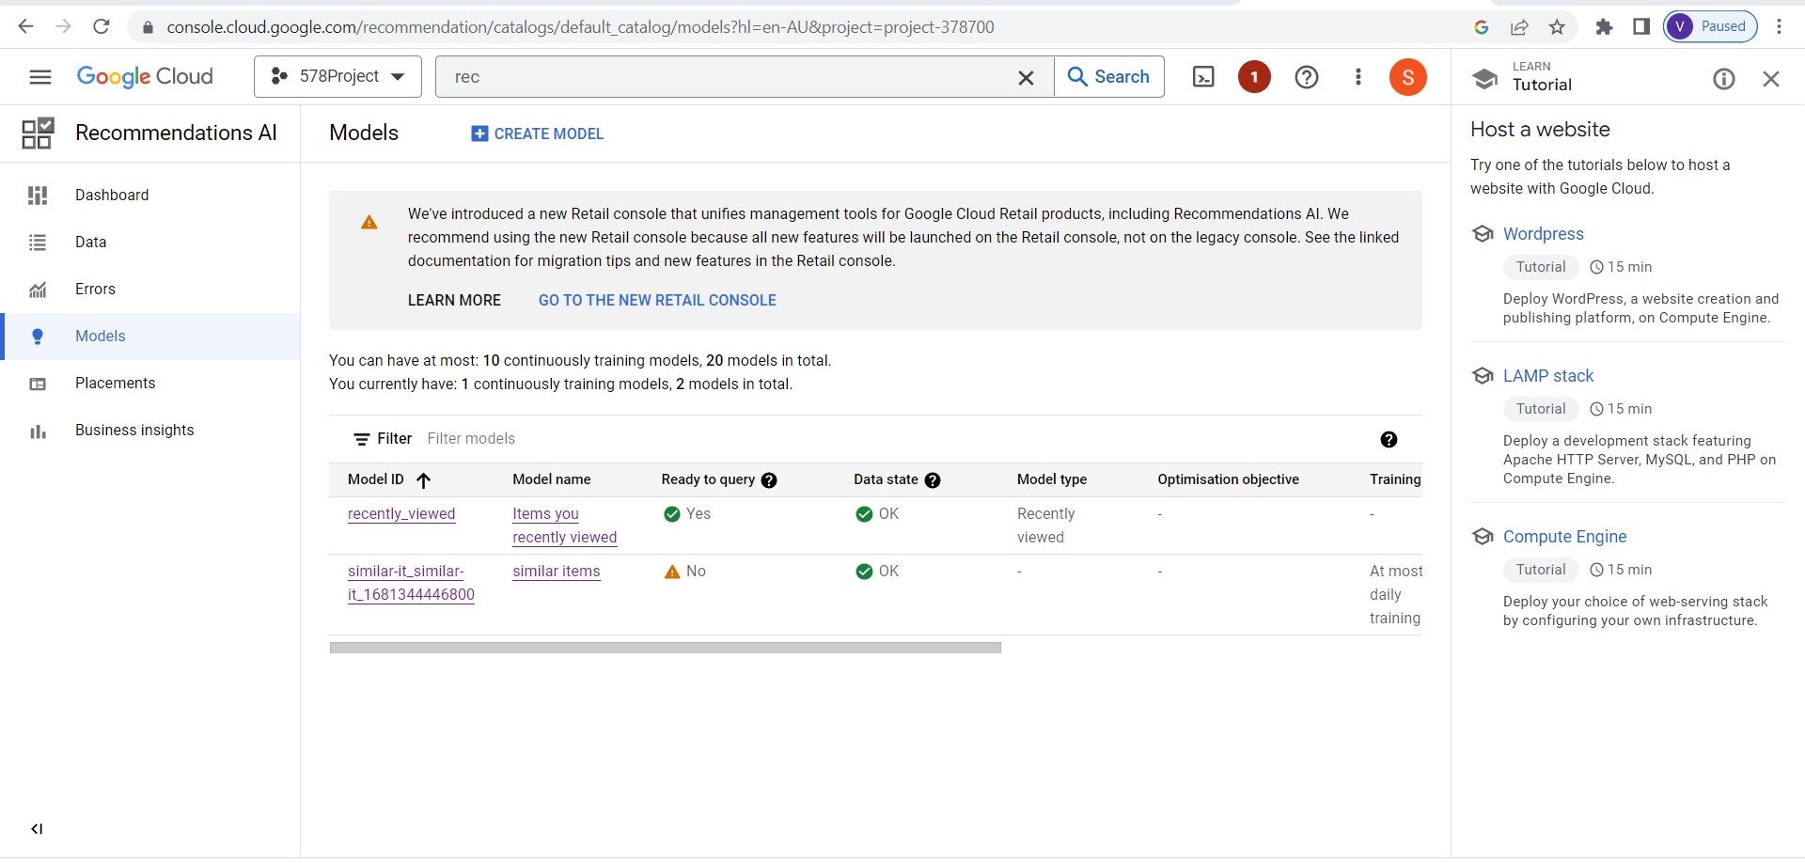

**STEP 5**

This is how our website shows recommendations to the customers based on their previous interactions with the products

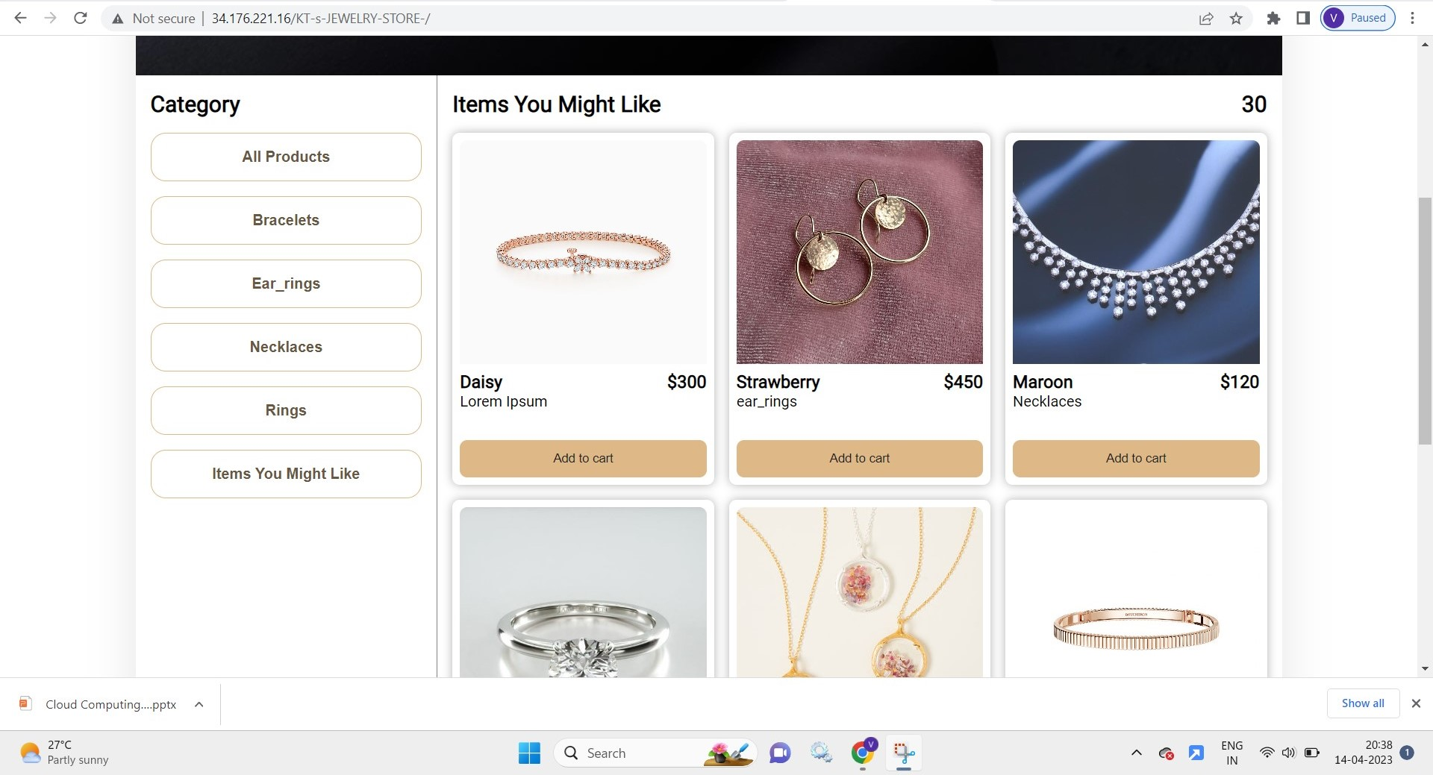

**STEP 6:**

This is our Engati chtabot which was integrated with our website to address the queries of the customers.

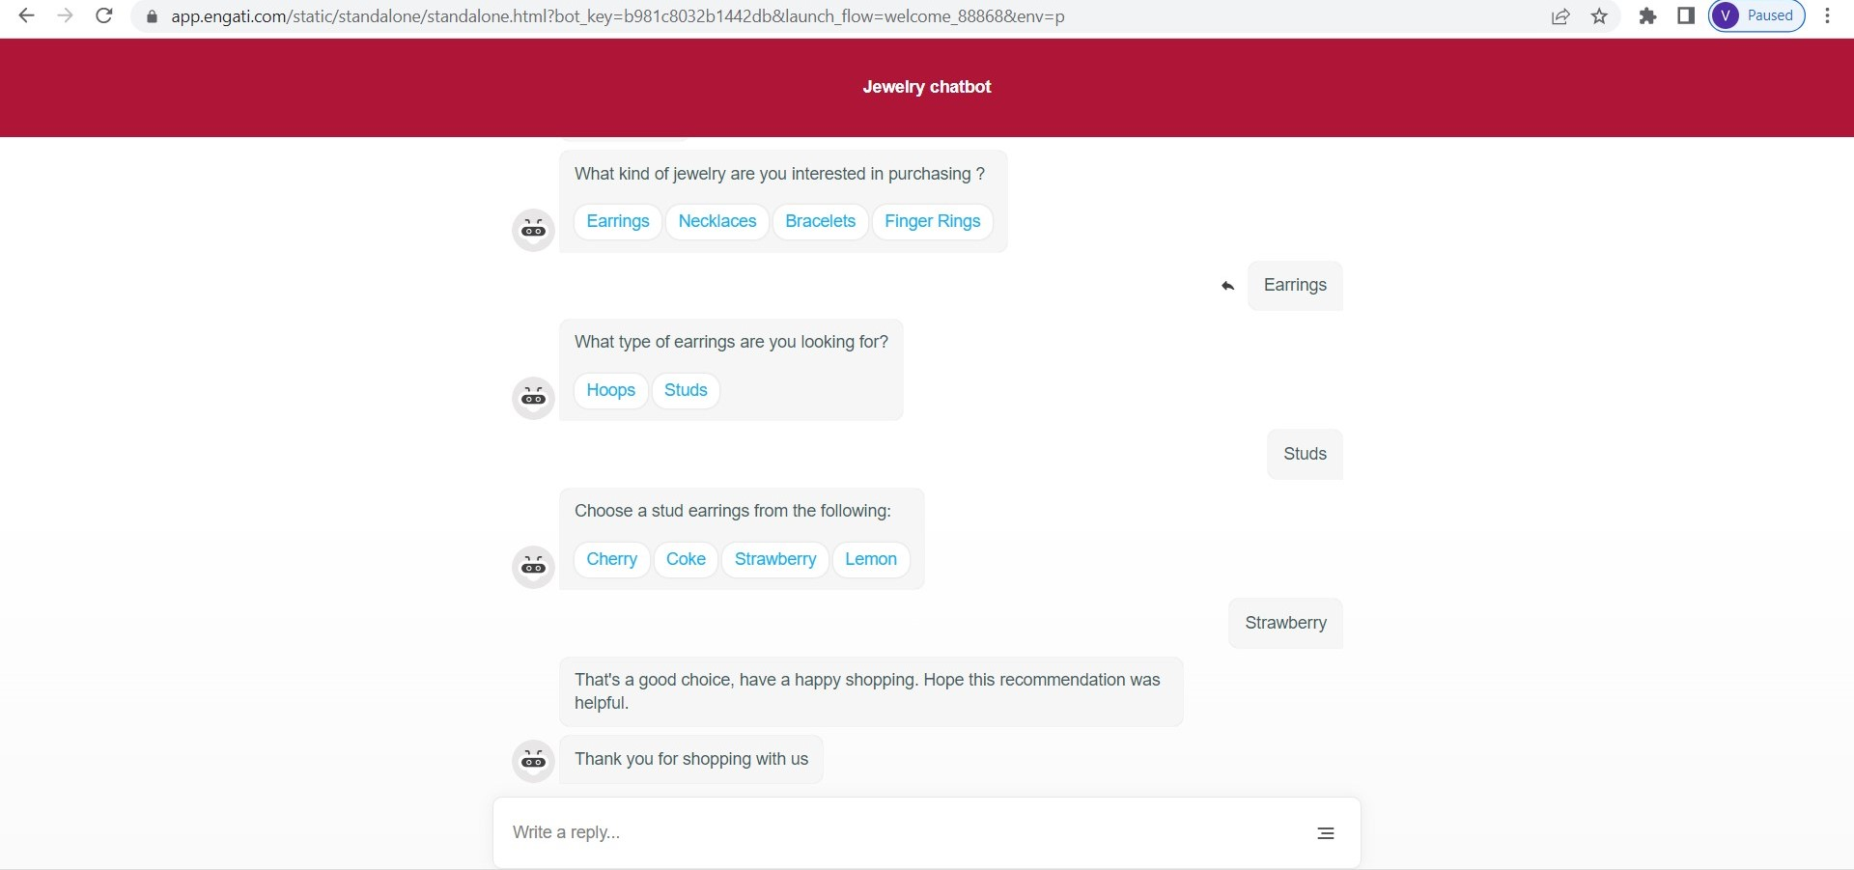

**Analysis of Results:**

1. The website is hosted and accessible publicly.
2. Multiple users used the website in order to generate the data.
3. The generated user data was used to train the “Similar Items“ Recommendations.

**Insights and Discussions Relevant to the Project:**

We were able to host the website using the deployment manager tool of GCP: LAMP Tech Stack. It already had apache 2.0, MySQL and PHP pre-installed in them. We deployed our chatbot using Engati chatbot creation tool.

**References:**

Artificial intelligence in recommender systems by Qiang Zhang, Jie Lu and Yaochu Jin

<https://www.researchgate.net/publication/346501646_Artificial_intelligence_in_recommender_systems>

Recommendation AI documentation of Google Cloud

<https://cloud.google.com/recommendations-ai/docs>

Application of Artificial Intelligence in Recommendation Systems and Chatbots for Online Stores in Fast Fashion Industry by Meshal Alduraywish, Bhuvan Unhelkar, Sonika Singh and Mukesh Prasad

<https://www.researchgate.net/publication/359449157_Application_of_Artificial_Intelligence_in_Recommendation_Systems_and_Chatbots_for_Online_Stores_in_Fast_Fashion_Industry>

# Ecommerce Website with Recommendation System Including Chatbot and Reverse Image Search by Preeti Badave, Bhakti Bhomaj, Bhargavi Bindu and Riddhi Shivarkar

<https://www.researchgate.net/publication/364054189_Ecommerce_Website_with_Recommendation_System_Including_Chatbot_and_Reverse_Image_Search>

Personalized Product Recommendation and User Satisfaction: Theory and Application by Priyadarsini Patnaik

<https://www.researchgate.net/publication/357499089_Personalized_Product_Recommendation_and_User_Satisfaction_Theory_and_Application>

# 

# The Application & Impact of Artificial Intelligence (AI) on E-Commerce by Ambar Srivastava

<https://www.researchgate.net/publication/356635263_The_Application_Impact_of_Artificial_Intelligence_AI_on_E-Commerce>

AI - Based Recommendation Systems: The Ultimate Solution for Market Prediction and Targeting by Sandra Habil, Sara El-Deeb and Noah El-Bassiouny

<https://www.researchgate.net/publication/367394298_AI-Based_Recommendation_Systems_The_Ultimate_Solution_for_Market_Prediction_and_Targeting>